QUESTION #1: What does the Vendor Registration Fee include?
ANSWER #1: Each Vendor Registration includes, Conference Attendance for 2 including the Welcome Reception and all meals, 2 chairs and a 6’ draped table in the main meeting room. Vendor Bingo cards will be provided to encourage traffic. Two attractive prizes will be drawn from completed cards.

QUESTION #2: What is the difference between a GOLD and REGULAR VENDOR TABLE?
ANSWER #2: Gold Tables will have a Premium Location & LOGO Signage for added visual recognition.

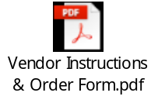QUESTION #3: Will electricity be available at the Vendor Booths?
ANSWER #3: Yes, electricity and other upgrades are available for purchase directly from the hotel.
Please see the following document for details and ordering.

QUESTION #4: Does the Vendor Registration include any marketing?
ANSWER #4: Yes, each Conference Attendee will receive a booklet containing Vendor name, logo and company info.

QUESTION #5: Will a Vendor Table Number and Map be provided in advance of the Conference?
ANSWER #5: Yes, about 7 days before the conference a map and table number assignment will be provided.
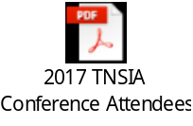
QUESTION #6: Will the Registered Vendors receive an advance list of the Conference Attendees?
ANSWER #6: Yes, about 7 days before the conference, each Registered Vendor and Sponsor will receive an advance list of the Conference Attendees (individual’s name and represented company). See last year’s list as an example.

QUESTION #7: What time can the Vendor Tables be set up?
ANSWER #7: Please plan to set up your Vendor Table from 11:00 AM – 1:00 PM on Thursday, September 6th. Vendor Tables MUST BE COMPLETED BEFORE the first presentation since they tables will be in the same room as the Conference Presentations.

QUESTION #8: What is the best way for vendors to unload/load promotional products for booths?
ANSWER #8: Please use East or South Entrances and proceed to the Birch-Chestnut-Poplar-Redbud-Sycamore Rooms for set up.

QUESTION #9: What are the shipping instructions at the hotel?
ANSWER #9: Address package as follows:
Responsible Party’s Name
TNSIA Conference Sept 6-7th - Birch-Chestnut-Poplar-Redbud-Sycamore Rooms
HOLD FOR ARRIVAL DATE OF WEDNESDAY, SEPT 5th
Embassy Suites
820 Crescent Centre Drive
Franklin, TN 37607

Schedule your shipment(s) to arrive no earlier than Tuesday, September 4th.

Handling Charges are as follows:
Boxes up to 36” x 24” x 24” = $5.00 per box
Larger boxes / Display cases = $10 per box
Pallets = $75.00 per pallet

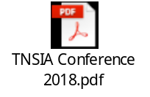QUESTION #10: How can we donate an item to the Kids’ Chance of Tennessee Silent Auction?
ANSWER #10: Please review and complete the following form.

